Database Management System

* Database management system is a software which is used to define, create and maintain a database and provides controlled access to the data. . For example: [MySQL](https://www.javatpoint.com/mysql-tutorial), [Oracle](https://www.javatpoint.com/oracle-tutorial), etc are a very popular commercial database which is used in different applications.

**Relational Database Management System (RDBMS)** is an advanced version of a DBMS. 

| DBMS | RDBMS |
| --- | --- |
| DBMS stores data as file. | RDBMS stores data in tabular form. |
| Data elements need to access individually. | Multiple data elements can be accessed at the same time. |
| No relationship between data. | Data is stored in the form of tables which are related to each other. |
|  |  |
|  |  |
|  |  |
| It stores data in either a navigational or hierarchical form. | It uses a tabular structure where the headers are the column names, and the rows contain corresponding values. |
| It deals with small quantity of data. | It deals with large amount of data. |
| Data redundancy is common in this model. | Keys and indexes do not allow Data redundancy. |

The different types of DBMS languages are as follows −

* Data Definition Language (DDL) − Create, Drop, Truncate, Alter,Rename.(CA Dr.)
* Data Manipulation language (DML) − Select, Insert, Delete, Update.(u.s id)
* Data Control Language (DCL) − Revoke, Grant.
* Transaction Control Language (TCL) − Rollback, Commit.

## Data Definition Language (DDL)

It is a language that allows the user to define the data and their relationship to other types of data. The DDL commands are: Create, Alter, Rename, Drop, Truncate.

## Data Manipulation Language (DML)

It is a language that provides a set of operations to support the basic data manipulation operation on data held in the database. The DML commands are: Insert, delete, update, select, merge, call.

## Data Control Language (DCL)

DCL is used to access the stored data. It is mainly used for revoke and grant the user access to a database. The DCL commands are: Grant, Revoke.

## Transaction Control Language (TCL)

TCL is a language which manages the transactions within the database. It is used to execute the changes made by the data manipulation language statements. The TCL commands are: Commit, Rollback.

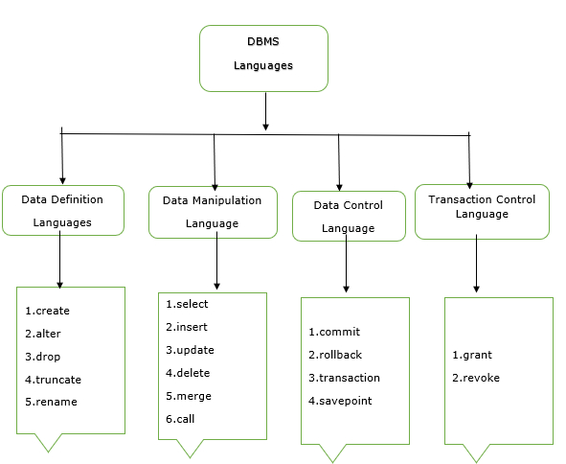

### **Question:- Are NULL values in a database the same as that of blank space or zero?**

No, a NULL value is very different from that of zero and blank space as it represents a value that is assigned, unknown, unavailable, or not applicable as compared to blank space which represents a character and zero represents a number.

Example: NULL value in “number_of_courses” taken by a student represents that its value is unknown whereas 0 in it means that the student hasn’t taken any courses

Question:- What is meant by ACID properties in DBMS?

ACID stands for Atomicity, Consistency, Isolation, and Durability in a DBMS these are those properties that ensure a safe and secure way of sharing data among multiple users.

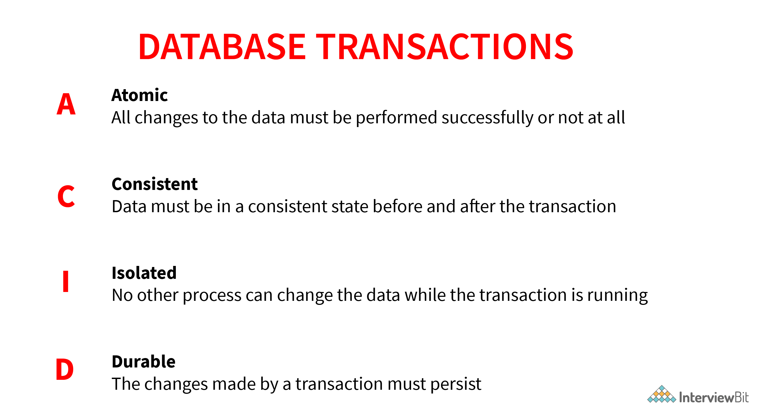

* **Atomicity**: This property reflects the concept of either executing the whole query or executing nothing at all, which implies that if an update occurs in a database then that update should either be reflected in the whole database or should not be reflected at all.
* **Consistency:** This property ensures that the data remains consistent before and after a transaction in a database.
* **Isolation:**This property ensures that each transaction is occurring independently of the others. This implies that the state of an ongoing transaction doesn’t affect the state of another ongoing transaction.
* **Durability:** This property ensures that the data is not lost in cases of a system failure or restart and is present in the same state as it was before the system failure or restart.

### .Qusetion:- Explain the difference between the DELETE and TRUNCATE command in a DBMS.

**DELETE command:**this command is needed to delete rows from a table based on the condition provided by the WHERE clause.

* It deletes only the rows which are specified by the WHERE clause.
* It can be rolled back if required.
* It maintains a log to lock the row of the table before deleting it and hence it’s slow.

**TRUNCATE command:** this command is needed to remove complete data from a table in a database. It is like a DELETE command which has no WHERE clause.

* It removes complete data from a table in a database.
* It can be rolled back even if required. ( truncate can be rolled back in some databases depending on their version but it can be tricky and can lead to data loss). Check this [link](https://codingsight.com/rollback-truncate-in-sql-server/) for more details
* It doesn’t maintain a log and deletes the whole table at once and hence it’s fast.

### Question:-What is meant by normalization and denormalization?

**Normalization** is a process of reducing redundancy by organizing the data into multiple tables. Normalization leads to better usage of disk spaces and makes it easier to maintain the integrity of the database.

**Denormalization** is the reverse process of normalization as it combines the tables which have been normalized into a single table so that data retrieval becomes faster. JOIN operation allows us to create a denormalized form of the data by reversing the normalization. +

### 6. Explain different types of Normalization forms in a DBMS.

### Following are the major normalization forms iDiagram Description automatically generated with medium confidence  8. What is a Primary Key?

The PRIMARY KEY constraint uniquely identifies each row in a table. It must contain UNIQUE values and has an implicit NOT NULL constraint.  
A table in SQL is strictly restricted to have one and only one primary key, which is comprised of single or multiple fields (columns).

**CREATE** **TABLE** Students ( /* Create table with a single field as primary key */

ID INT **NOT** **NULL**

Name VARCHAR(255)

**PRIMARY** KEY (ID)

);

### What is a UNIQUE constraint?

A UNIQUE constraint ensures that all values in a column are different. This provides uniqueness for the column(s) and helps identify each row uniquely. Unlike primary key, there can be multiple unique constraints defined per table. The code syntax for UNIQUE is quite similar to that of PRIMARY KEY and can be used interchangeably.

**CREATE** **TABLE** Students ( /* Create table with a single field as unique */

ID INT **NOT** **NULL** **UNIQUE**

Name VARCHAR(255)

);

### What is a Foreign Key?

A FOREIGN KEY comprises of single or collection of fields in a table that essentially refers to the PRIMARY KEY in another table. Foreign key constraint ensures referential integrity in the relation between two tables.  
The table with the foreign key constraint is labeled as the child table, and the table containing the candidate key is labeled as the referenced or parent table.

**CREATE** **TABLE** Students ( /* Create table with foreign key - Way 1 */

ID INT **NOT** **NULL**

Name VARCHAR(255)

LibraryID INT

**PRIMARY** KEY (ID)

**FOREIGN** KEY (Library_ID) **REFERENCES** Library(LibraryID)

);

### Question:- What is a Join? List its different types.

The SQL Join clause is used to combine records (rows) from two or more tables in a SQL database based on a related column between the two.

## Different Types of SQL JOINs

Here are the different types of the JOINs in SQL:

* (INNER) JOIN: Returns records that have matching values in both tables
* LEFT (OUTER) JOIN: Returns all records from the left table, and the matched records from the right table
* RIGHT (OUTER) JOIN: Returns all records from the right table, and the matched records from the left table
* FULL (OUTER) JOIN: Returns all records when there is a match in either left or right table

